
St. Louis Public Schools
Standards-Based Blended Learning Lesson Planner

Weekly Instructional Planner
Name | P. Sutton | Date | September 12 - 16, 2022 | Grade & Subject | 1st
Lesson Topic | What is energy?
Lesson Objectives | Content Objective(s) |  |  | Language Objective (ESOL)
 | I can:  - identify sources of energy  - observe energy sources  - describe energy sources using temperature words (hot or cold)  - explain temperature changes that are caused by energy sources |  |  | - make observations to describe the source of energy that causes an increase in  the temperature of an object:  - explain how a source of energy can causes an increase in the temperature of an object  - describe, using evidence that the sun is a source of energy that can  increase of energy  - identify the source of energy that increases the temperature in an  object  - communicate the cause and effect relationship of an object and light  source
Focus Standard(s) | Standard |  |  | Prior Knowledge and/or Unfinished Learning Needs
 | 1.PS3.A.1 Identify the source of energy that causes an increase in the temperature of an object (sun – stove – flame - lightbulb) |  |  | Students will:  - make observation to determine the effect of sunlight on Earth’s surface  - with prompting and support, use tools and materials to design and build a structure that will reduce the warming effect of sunlight on an area
Essential Question & Vocabulary | Essential Question |  |  | Lesson Vocabulary
 | How is energy transferred and conserved |  |  | energy – the ability to do work  observation – the act of careful watching and listening  temperature – a measurement of heat measured in degrees
List of resources or strategies related to learner’s style & needs embedded throughout lesson | Cultural Context Differentiation |  |  | Integrated Technology
Mystery Science NG Science
Nearpod
PBIS Science
 | Multi-Tiered Systems of Support (MTSS) Resources

 | MONDAY | TUESDAY | WEDNESDAY | THURSDAY | FRIDAY
 | Please be mindful to include specific learning activities, vocabulary strategies, instructional methods, differentiation, and check for understanding in each component of the lesson, as appropriate. Cultural Context Differentiation and Blended Learning should be integrated into all components of the lesson plan. Please see the Lesson Plan Guide Book for examples and more information.
Do Now  (Prior Knowledge or Unfinished Learning) | - Have students get their notebooks open up to a new page  - write the date  - then write: Energy |  | Whiteboard Splash: Draw or write as many energy sources as you can in 5 minutes
Engage  (Hook / Launch) | Introduce the word energy  Ask students to brainstorm with a partner “What is energy? |  | Students log into Nearpod:  https://nearpod.com/t/science/kindergarten/types-of-energy-L77551233  View soufces of energy in real world
Explore  (Activities) | - Share out  - Students record definition of energy |  | NG Science  https://www.youtube.com/watch?v=rkZZjM6Oiw8
Explain  (Demonstrate Learning) | Introduce vocabulary: energy observation - temperature  - Introduce the different types of energy |  | Review vocabulary  Response in Nearpod activity
Elaborate.  (Extend Thinking) | Students do a scavenger hunt in the classroom or walk through building identifying different types of energy
Evaluate  (Exit Ticket) | 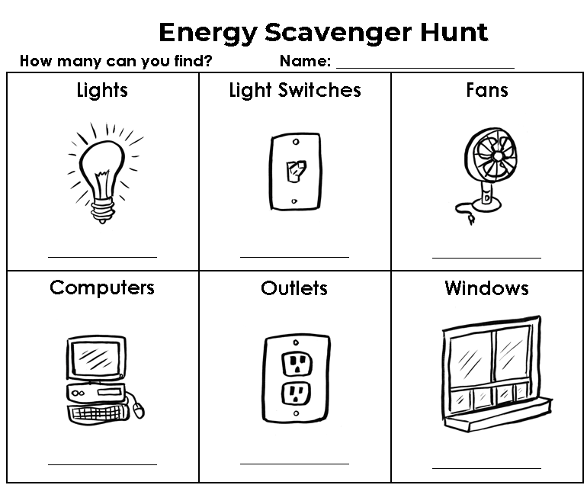 |  | 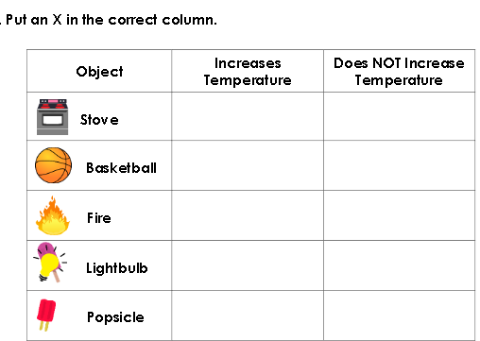
Closure  (Brief Review) | Student responses after scavenger hunt – generate list of sources of energy
Extended Practice (Homework)

Lesson Reflections
Prompts to help you get started on your lesson reflection...
- Did scholars demonstrate, through their work and activities, that they are moving towards proficiency? If so, how do you know? What pieces of scholar evidence did you use to determine this?
- How have you / will you provide feedback to scholars?
- What questions or activities did you plan for to help scholars increase their depth of knowledge (DOK)?
- Were the scaffolds planned in last week’s instruction effective? What new supports might be added this week to help scholars demonstrate proficiency?
- How are formative assessments or exit tickets being used for the following day’s Do Now?
- How are you embedding and/or using vocabulary throughout your lesson?

